1. Test for state miss. Result is right.



1. Test for fork miss. Exception!  
   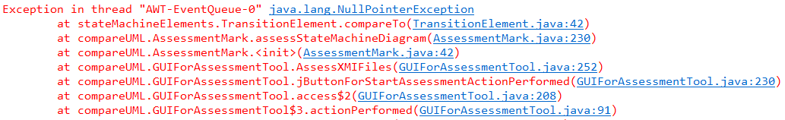  
   
2. Test for choice miss. Exception and problem are same with above
3. Test for junction miss. Exception and problem are same with No.2.
4. Test for sub state machine (a large state which contains some elements). Exception and problem are same with No.2
5. GUI problem. If file name is too long, user cannot see the result in summary window of GUI  
   